For Virtual Machine creation, we have to create a Virtual Network .For Virtual Network creation, we go to market place of azure for virtual network creation.

We have to choose the network range i.e 10.0.0.0/24 or according to our requirement.

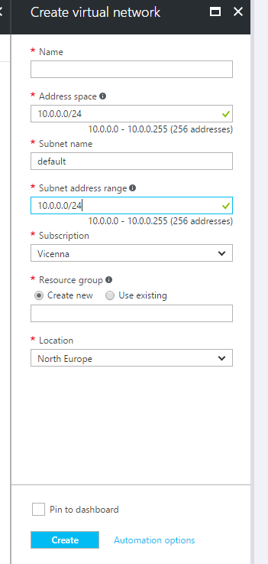

We have to add subnet range in a virtual Network. This subnet range should be in same virtual Network range. We can add more than one subnet in a particular virtual network.

After the creation of the Virtual Network, we go for Virtual Machine creation. The creation of virtual Machine involve many steps.

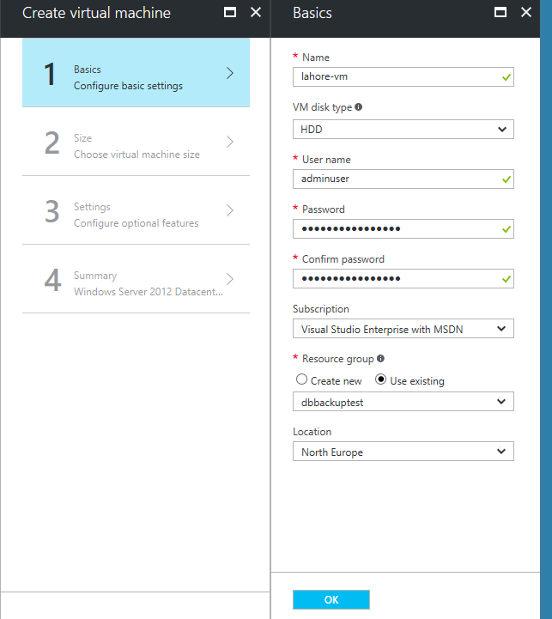

We select the HDD disk type as this is cheaper than SSD disk Type.

After the completion of the basics for virtual machine, we proceed to Sizing of the VM.

After the selection of proper sizing we move on configuration setting of the Virtual Machine.

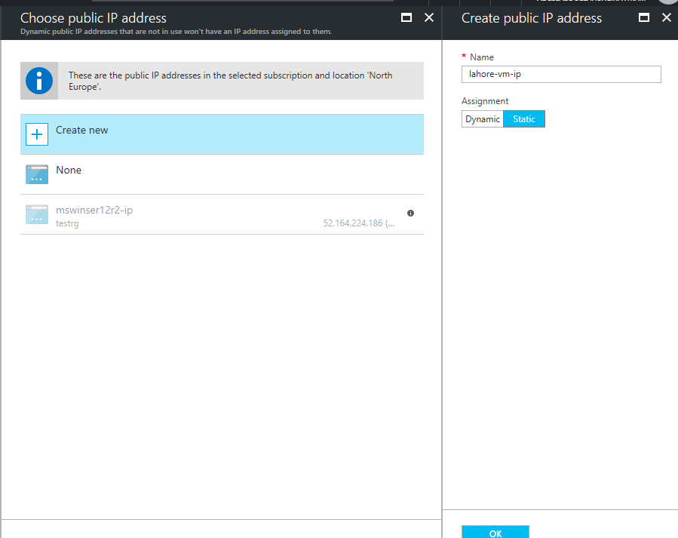

We select the Static IP for VM. We have to add network Security group for the VM. We normally add the default values for network security group. These rules are for inbound/outbound traffic for a VM.

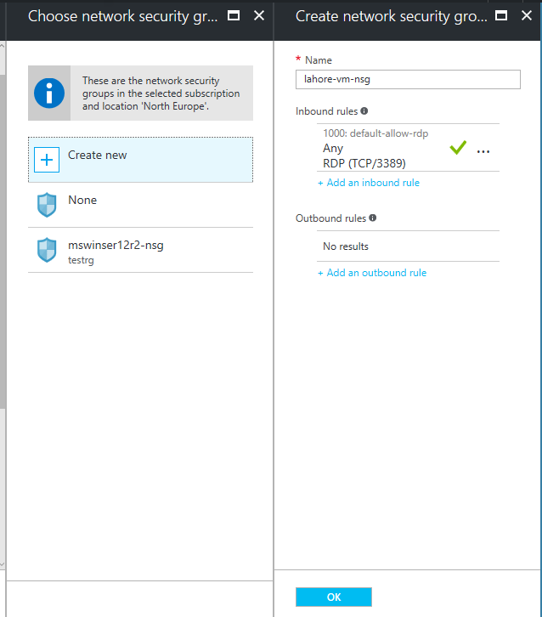

After the selection of the configuration settings we go to summary section for the verification of the Virtual Machine detail

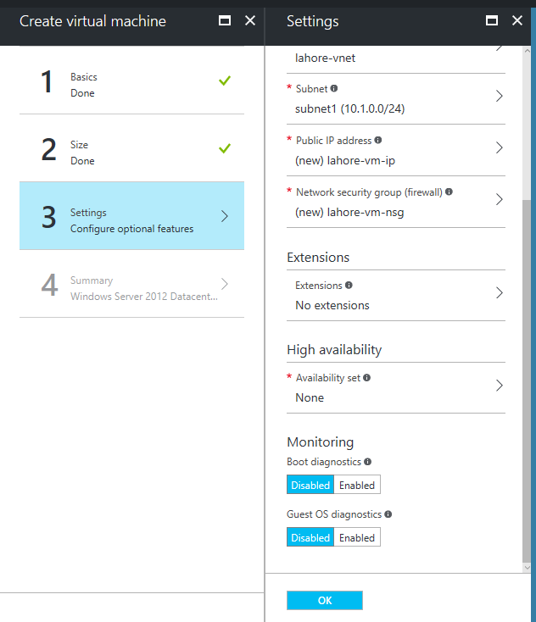

After the verification of detail, we create a Virtual Machine.

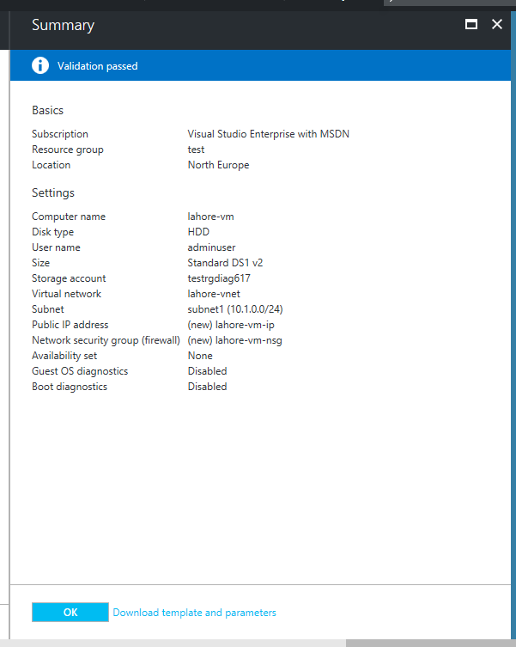

We have to create the Virtual Network Gateway for communication of our VNET with some other network through VPN etc.

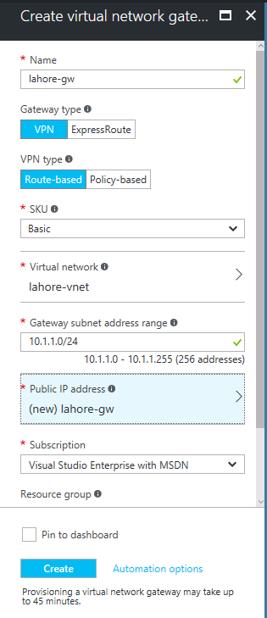

Virtual Network Gateway normally take up to 45 minutes for creation.

We create the local Network Gateway for client side. We take Different IP ranges from client and insert into Local network gateway setting. We give the public IP after taking it from client.

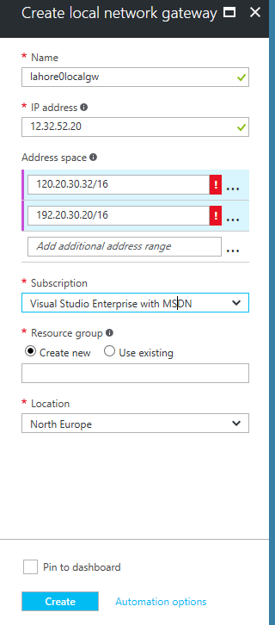

After the local Network Gateway connection, we make site to site connection (VPN Tunnel) with the virtual Network Gateway.We enter the preshared(PSK) key in azure portal and share with client.

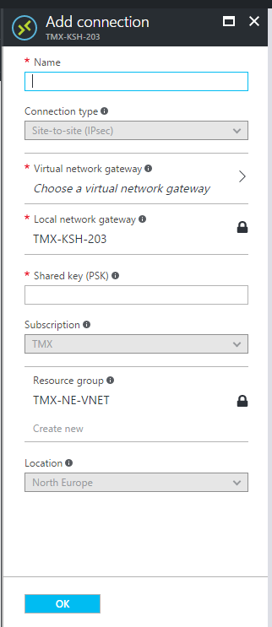

We wait for client verification at their end and test the VPN by ping certain IP’s using Newly made VM in the azure.

For point-to-site Net, we go to the particular app and under connections we have to configure it with virtual network Gateway. We just have to give some IP range and add it app.